|  |
| --- |
| **Course: CSE 462 - Network Analysis and Design**  **LAB 1 – Basic Network Configuration**  **Duration: 3 hours** |

|  |  |
| --- | --- |
| **Group ID** | *Write your name here* |
| **Student name** | *Write your ID here* |
| **Final Score** |  |

**Lab Exercise Submission**

Students are responsible for submitting the requested work files by the stated deadline for the highest scores. Late submissions will NOT be accepted. It is the student’s responsibility to submit the report on time.

**Objective:** This lab is to guide students how to setup some basic configuration on network devices.

**NOTE:** *Students should read the guideline carefully before conducting Lab experiments and writing the final report.*

**- - - Good luck - - -**

**Students are required to perform the following tasks:**

**TASK 1. BUILD A BASIC LAN NETWORK WITH CISCO SWITCH**

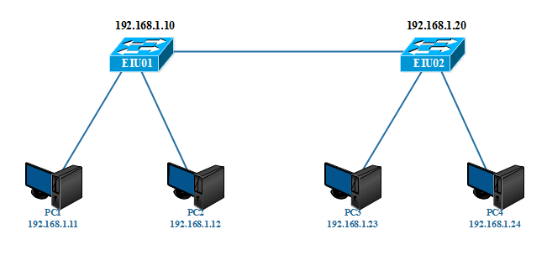

REQUIRE:

* Group 1: Subnet 192.168.10.0/24
* Group 2: Subnet 192.168.20.0/24
* Group 3: Subnet 192.168.30.0/24

1. Restore all devices (switch, router, etc.) to default configuration
2. Configure the IP address of all computers in the network
3. Connect to each **switch** device using console port (i.e. use putty or any serial communication program)
4. Configure the hostname
5. Set IP address (for management purpose)
6. Configure an EXEC mode password (eiu@123)
7. Configure a password for console connections (cisco@123).
8. Disable DNS lookup
9. Display all configuration on each switch
10. Save all configuration to NVRAM

***Answer:***

**TASK 2. WORKING WITH CISCO SWITCH**

Use the network topology in the previous task and perform the following activity:

1. Display the CAM table on Switch
2. Display the ARP cache in computers
3. Delete CAM table and ARP cache
4. From PC1, ping to PC2
5. Display CAM table and ARP cache; See what happens and explain more details
6. Repeat step (4) and (5) with other PCs in the network

***Answer:***

**TASK 3. REMOTE MANAGEMENT WITH TELNET SERVICE**

1. Enable telnet on each switch
2. From a computer, connect to each switch device via telnet service
3. When successfully connected, try to perform some basic configuration on switch
4. Save the configuration file of each switch to a computer (using TFTP service)

***Answer:***

**TASK 4. REMOTE MANAGEMENT WITH SSH SERVICE**

1. Enable SSH on each switch
2. From a computer, connect to each switch device via SSH service
3. When successfully connected, try to perform some basic configuration on switch

***Answer:***